Hierarchy chart is used to display data maintaining the hierarchy. Expand icon is shown beside the elements having level below them and collapse icon is shown bedside the already expanded elements.

Hierarchy is generated in the order of columns provided by the user. The user can select any number of columns. The chart dynamically changes if order of columns is changed or some columns are added/removed.

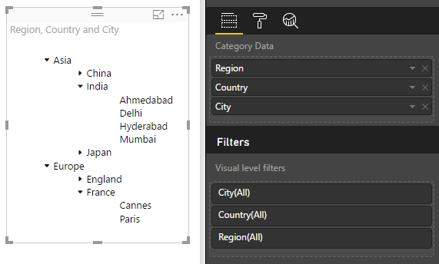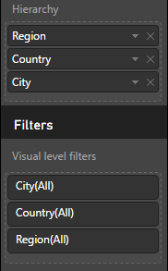

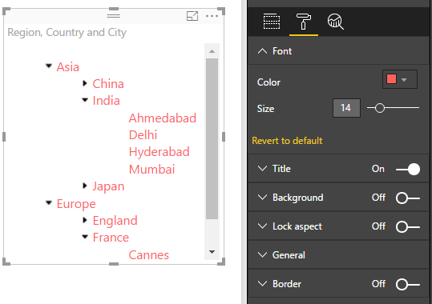

Configurations:

1. Font
2. Color: To change the font color of the displayed data
3. Size: To change the font size of the displayed data

Whenever these formatting options are applied, the expand/collapse state of the elements are retained. If the data overflows due to increase in font size, scrollbar is shown so that user can access the whole data.